Latin-American nationals lodge record numbers of asylum applications in February 2019

* 15TH APRIL 2019

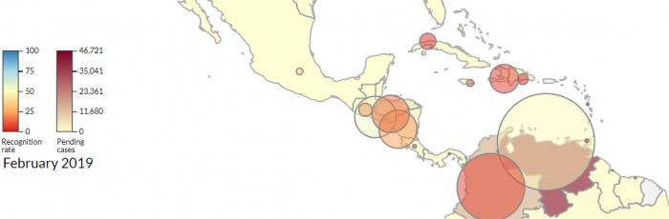

***Venezuelans were the second most common applicants in the EU+.***

In February 2019, some **57 000 applications** for international protection were lodged in the EU+. Despite a small decrease compared to the first month of the year, this monthly figure remained higher than the average over the past twelve months, and considerably higher than applications in February 2018 (46 000 applications).

Most applications were lodged by nationals of Syria, Venezuela, Afghanistan, Iraq and Nigeria. These five citizenships together made up one third of all applicants in February.

While most citizenships lodged fewer applications than in previous months, nationals of many Latin-American countries continued to seek international protection in larger numbers. **Venezuela** became the second main country of origin of applicants in the EU+, with almost 4 000 applications (+51% from January). With few first-instance decisions being issued, the number of Venezuelans awaiting a decision in the first instance also grew considerably and now stands at 33 800.

**Colombian** applications reached a record high in February with some 1 937 claims (+47% from January), more than tripling the number of applications compared to a year earlier, and becoming the tenth most common nationality of applicants for international protection in the EU+. The number of **Nicaraguan** applicants also increased substantially, from nine (9) in February 2018, to 616 in February 2019.

Nigerians also lodged increasing numbers of applications for the second consecutive month, following a drop in the latter months of 2018. Nigeria re-entered the top five of countries of origin for the first time since June 2018.

Find out more about the latest asylum trends in the EU+ [here](https://www.easo.europa.eu/latest-asylum-trends).